Temperature Control for Research and Industry

Personal Reaction
Station
Manual

Index

Safety Notices . . . . . . . . . . . . . . . . . . . . . . . . . . . . . . . . . . . . . . . . . . . . . . . 3
Controller Description . . . . . . . . . . . . . . . . . . . . . . . . . . . . . . . . . . . . . . . . 4
Entering a setpoint into the Controller . . . . . . . . . . . . . . . . . . . . 5
Description of Timer Components on PRS/Timer . . . . . . . . . . 6
Using the Temperature Ramp Feature . . . . . . . . . . . . . . . . . . . 7
Personal Reaction Station Reactor . . . . . . . . . . . . . . . . . . . . . . . . . . . . . . . . 8
Fluid Connections . . . . . . . . . . . . . . . . . . . . . . . . . . . . . . . . . . . 9
Inert Gas Connection . . . . . . . . . . . . . . . . . . . . . . . . . . . . . . . . 9
Septum Replacement . . . . . . . . . . . . . . . . . . . . . . . . . . . . . . . 10
Heating Applications . . . . . . . . . . . . . . . . . . . . . . . . . . . . . . . . . 10
Cooling Applications . . . . . . . . . . . . . . . . . . . . . . . . . . . . . . . . . 10

Block and Solution Temperature Sensors . . . . . . . . . . . . . . . . . . . . . . . . 11
Selecting Between the Block and Solution Sensors . . . . . . . . . . 11
Reaction Temperature Accuracy and Homogeneity . . . . . . . . . . . 12
Block (Internal) Sensor Method . . . . . . . . . . . . . . . . . . . . . . . . . . 12
Solution (External) Sensor Method . . . . . . . . . . . . . . . . . . . . . . . . 14

You’ve purchased the most versatile controller available to the research community. We’re confident it can regulate ANY heating/cooling situation you’ll ever encounter. If the information in this manual isn’t adequate to make your application work, call our Engineering Department for assistance.

Warranty
J-KEM Scientific, Inc. warrants this unit to be free of defects in materials and workmanship and to give satisfactory service for a period of 12 months from date of purchase. If the unit should malfunction, it must be returned to the factory for evaluation. If the unit is found to be defective upon examination by J-KEM, it will be repaired or replaced at no charge. However, this WARRANTY is VOID if the unit shows evidence of having been tampered with or shows evidence of being damaged as a result of excessive current, heat, moisture, vibration, corrosive materials, or misuse. This WARRANTY is VOID if devices other than the reaction block supplied with this unit are powered by the controller. Components which wear or are damaged by misuse are not warranted. This includes contact points, fuses and solid state relays.
THERE ARE NO WARRANTIES EXCEPT AS STATED HEREIN. THERE ARE NO OTHER WARRANTIES, EXPRESSED OR IMPLIED, INCLUDING BUT NOT LIMITED TO THE IMPLIED WARRANTIES OF MERCHANTABILITY AND OF FITNESS FOR A PARTICULAR PURPOSE. IN NO EVENT SHALL J-KEM SCIENTIFIC, INC. BE LIABLE FOR CONSEQUENTIAL, INCIDENTAL OR SPECIAL DAMAGES. THE BUYER'S SOLE REMEDY FOR ANY BREACH OF THIS AGREEMENT BY J-KEM SCIENTIFIC, INC. OR ANY BREACH OF ANY WARRANTY BY J-KEM SCIENTIFIC, INC. SHALL NOT EXCEED THE PURCHASE PRICE PAID BY THE PURCHASER TO J-KEM SCIENTIFIC, INC. FOR THE UNIT OR UNITS OF EQUIPMENT DIRECTLY AFFECTED BY SUCH BREACH.

J-KEM Scientific, Inc.  858 Hodiamont Ave.  St. Louis, MO 63112  USA | Phone: (314) 863-5536  FAX: (314) 863-6070  Web site: http://www.jkem.com  E-Mail: jkem911@jkem.com
Safety Notices

Solvents and Vapors
Care must be taken when using electric equipment around flammable organic solvents. Always turn off mains power before disconnecting the power cord from the body of the Personal Reaction Station. When possible it is recommended that the Personal Reaction Station be placed outside of the research hood and the reactor be placed inside of the hood.
CAUTION: This equipment should only be operated by qualified personnel knowledgeable in laboratory procedures.

Symbols
Power Switch: 1 - Mains power (120vac for USA and Canada) (230vac for Europe) is ON
0 - Mains power (120vac for USA and Canada) (230vac for Europe) is OFF

 | Caution. Risk  of electric  shock. |  | Caution. No  user serviceable  parts. |  | Protective conductor terminal. Earth Ground.

General Notice
WARNING: If equipment is not used as specified in this manual, the protection provided by this equipment may be impaired.

CAUTION: When operating this equipment insure that the reaction block is located away from flammable object.

Stability
The temperature controller for the Personal Reaction Station is equipped with a side mounting clamp. The controller should not be clamped to a free standing ring stand that can tip over. The PRS controller should only be clamped to lattice networks securely attached to a bench or laboratory hood.

Power
Voltage: 120-240 VAC @ 50-60Hz
Wattage: 600 watts
Fusing (USA): 5 amp fast acting (F) 120 Vac fuses
Fusing (Europe): 3 amp fast acting (F) 240 Vac fuses

Environmental
Indoor use
Altitude up to 2000 meters
Operating temperatures of 5o C to 40o C
Maximum relative humidity of 80% for temperature up to 31o C decreasing linearly to 50% relative humidity at 40o C.
Installation category II

WARNING: The PRS controller is exclusively made for use with J-KEM Scientific’s Personal Reaction Station. Using any other heater with the controller will void the warranty and create a significant safety hazard.

Controller Description

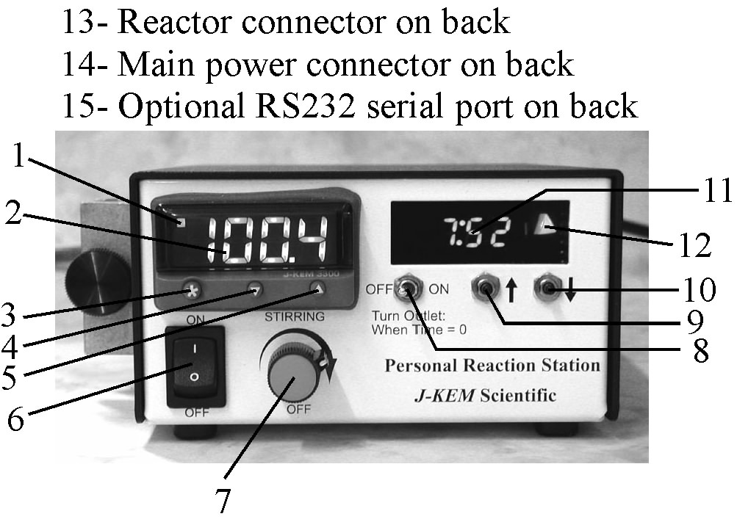
1. Indicates that heating power is being applied to the heater when lit.

2. Temperature Display. Shows temperature of the process as the default display. Shows set point temperature (i.e. desired temperature) as a blinking number when ‘*’ button is held in.

3. Control Key. When held in, the display shows the set point temperature. To decrease or increase the set point, press the ‘t’ key (4) or ‘s’ key (5), while simultaneously holding in the control key. The set point appears as a blinking number in the display.

4. Lowers set point when ‘*’ button (3) is simultaneously pressed.

5. Raises set point when ‘*’ button (3) is simultaneously pressed.

6. Controller On/Off switch.

7. Magnetic stirrer speed adjustment. Adjusting this knob sets the speed for magnetic stirring in all six reactor positions.

8. Timer Switch. This switch, in conjunction with the timer, determines if power is applied to the heater. See Section *. The label ‘When time = 0 turn outlet:’ has reference to the time remaining in the display (8).

9. Increases the time remaining in the timer when pressed.

10. Decreases the time remaining in the timer when pressed.

11. Displays the time remaining in the timer in the format of ‘Hr:Min’.

12. Indicates whether the timer section will allow power to be ON or OFF to the heating block. This LED is lit when the timer section will allow the controller to heat the reaction block and off when the reaction block will not be heated (see section titled ‘Timer Controls’).

13. Personal reaction station reactor connector. Only J-KEM’s personal reaction station should be connected to the round multi-pin connector. Connecting any other device will cause a significant safety hazard and voids the warranty.

14. Mains Power Connection. The fuses internal to this connection must only be replaced with fast acting (F) fuses of the following amperage:
120 VAC input (USA and Canada): 5 amps.
220-240 VAC input (Europe): 3 amps.

15. Optional serial communication port for PC control and data logging.

Entering a Setpoint into the Controller

1. Turn power on to the digital temperature controller. The default display (when no buttons are being pressed) of the controller is the current reactor temperature.

2. To see the current setpoint temperature
(i.e., the desired temperature), press and hold in the ‘*’ button on the front of the digital meter. The current setpoint appears as a blinking number in the display. To enter a new setpoint, hold in the ‘*’ button on the front of the meter. While holding in the ‘*’ button press either the s button to increase, or the t button to decrease the setpoint. When the desired temperature is present in the display, release all the buttons.
Timer Controls

The timer section turns heating to the reactor either ON or OFF in an unattended operation when the time in the timer counts to zero. To adjust the time in the timer press the [UP arrow] or [DOWN arrow] buttons (9 & 10) to increase or decrease the displayed time. The format of the display is ‘Hr : Min’. A simple way to know whether heat is being applied to the reactor is by the state of LED 12 which is lit when the heat is on and not lit when it’s off.
The position of switch 8 determines whether heat to the reactor is ON or OFF depending on whether any time present in the timer. To understand the effect of switch 8, take the example where switch 8 is set to the OFF position (i.e., “When time = 0 (zero), turn outlet: OFF”). If there is time present in timer 11 then heat to the reactor would be ON, since time ≠ 0. When the timer counts down to zero heat to the reactor is turned OFF because this fills the requirements of the position of switch 8 (i.e., ‘When time = 0, turn outlet: OFF). When not using the timer, the normal position of switch 8 is the ON position with no time in the timer window 11. If switch 8 is set to “When time = 0, turn outlets: ON”, heat to the reactor is on since the time does equal zero. The effect of the position of switch 8 on heating the reactor is summarized below.

Switch 8 | Time Remaining | Reactor | LED 12
Position | in Timer | Heating: | is | Comment
[When time = 0  turn outlet:] | Zero | OFF | OFF
OFF | >Zero | ON | ON | Heat to the reactor remains ON until the timer counts down to zero, at which point heat is turned OFF and stays off indefinitely.
[When time = 0  turn outlet:] | Zero | ON | ON
ON | > Zero | OFF | OFF | Heat to the reactor remains OFF until the timer counts down to zero, at which point heating turns ON and stays on indefinitely.

WARNING: A potential danger exists when using the timer to turn the reactor ON when the timer counts to zero. In the event of a power failure, any time present in the timer is lost. When power comes back on, the timer resets to zero which results in heat to the reactor being turned ON. Therefore, only processes that pose no danger when heated indefinitely should be set up to turn on when the timer counts to zero.
Using the Temperature Ramp Feature.

The controller can be programmed to heat or cool at a user specified rate. A single temperature ramp step and hold step are standard in all J-KEM controllers. Optionally, the controller can have up to 126 temperature ramps steps.

A temperature ramp consists of a ramp step (heating or cooling) and a soak step. The rate of temperature ramping and the duration of the soak step are set by the user.
To start a temperature ramp follow these steps.

1. Set up the reaction, turn on the controller, and enter the desired ramp rate into the meter by:
Place the controller in programming mode by holding in both the t and s keys on the front of the temperature meter until the word “tunE” appears in the display, then release both keys.
Press the s key 8 times until the word “SPrr” appears in the display. Next, hold in the ‘*’ key, then while holding in the ‘*’ key press the s or t key until the desired ramp rate appears in the display. Let go of all the keys. Ramp rates are entered in units of degrees/hour and has a range of 0 to 9900 degrees/hour.

2. Enter the soak time for the reaction. The soak time is the amount of time the reaction remains at the final setpoint temperature before turning heating off. Soak time can be set to a value of “- -“, or 0-1440 minutes. When soak time is set to “- -“ (two dashes in the display. This setting is one setting below ‘0’), the reaction ramps to the setpoint and then remains at the setpoint indefinitely. When set to a duration of ‘0’ minutes, the reaction heats to the setpoint and then turns off. When set to any value between 1-1440 minutes, the reaction heats to the setpoint and then stays at the setpoint for the number of minutes entered before turning off.
Press the s key 2 times until the word “SoAk” appears in the display. Next, hold in the ‘*’ key, then while holding in the ‘*’ key press the s or t key until the desired soak time appears. Let go of all the keys.
Exit programming mode by holding in both the t and s keys on the front of the temperature meter until the temperature appears in the display.

3. Enter the desired setpoint into to the controller. Start temperature ramping by:
Place the controller in programming mode by holding in both the t and s keys on the front of the temperature meter until the word “tunE” appears in the display, then release both keys.
Press the s key 9 times until the word “SPrn” appears in the display. Next, hold in the ‘*’ key, then while holding in the ‘*’ key press the s or t key until the word “On” appears in the display. Let go of all the keys.

Setting the value of “SPrn” to “Off” turns off ramping.
Exit programming mode by holding in both the t and s keys on the front of the temperature meter until the temperature appears in the display.

Personal Reaction Station Reactor

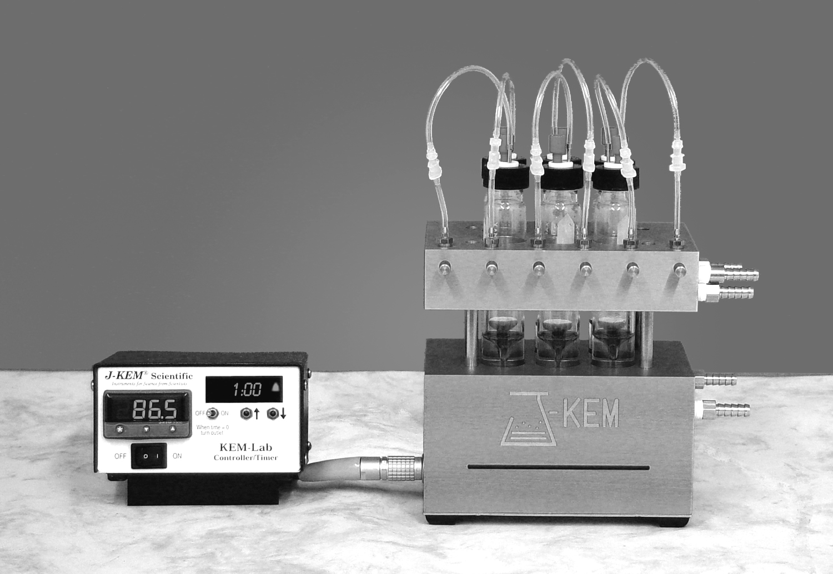

Connecting the Personal Reaction Station (PRS) Controller to the PRS Reactor involves nothing more than connecting the gray power cord between the silver plug on the reactor and the black receptacle on the back of the controller. Both the power and temperature sensor connections are made when the gray cord is attached. An accessory cord is available that separates the power and temperature sensor connections which allows the use of an external temperature sensor. An external sensor can be placed at any appropriate point on the reactor, but is usually placed in one of the reaction vials to sense solution temperature.
The temperature limit when using the internal electric heater is 130º C. Cooling fluids can be anything from liquid nitrogen to tap water.

Fluid Connectors

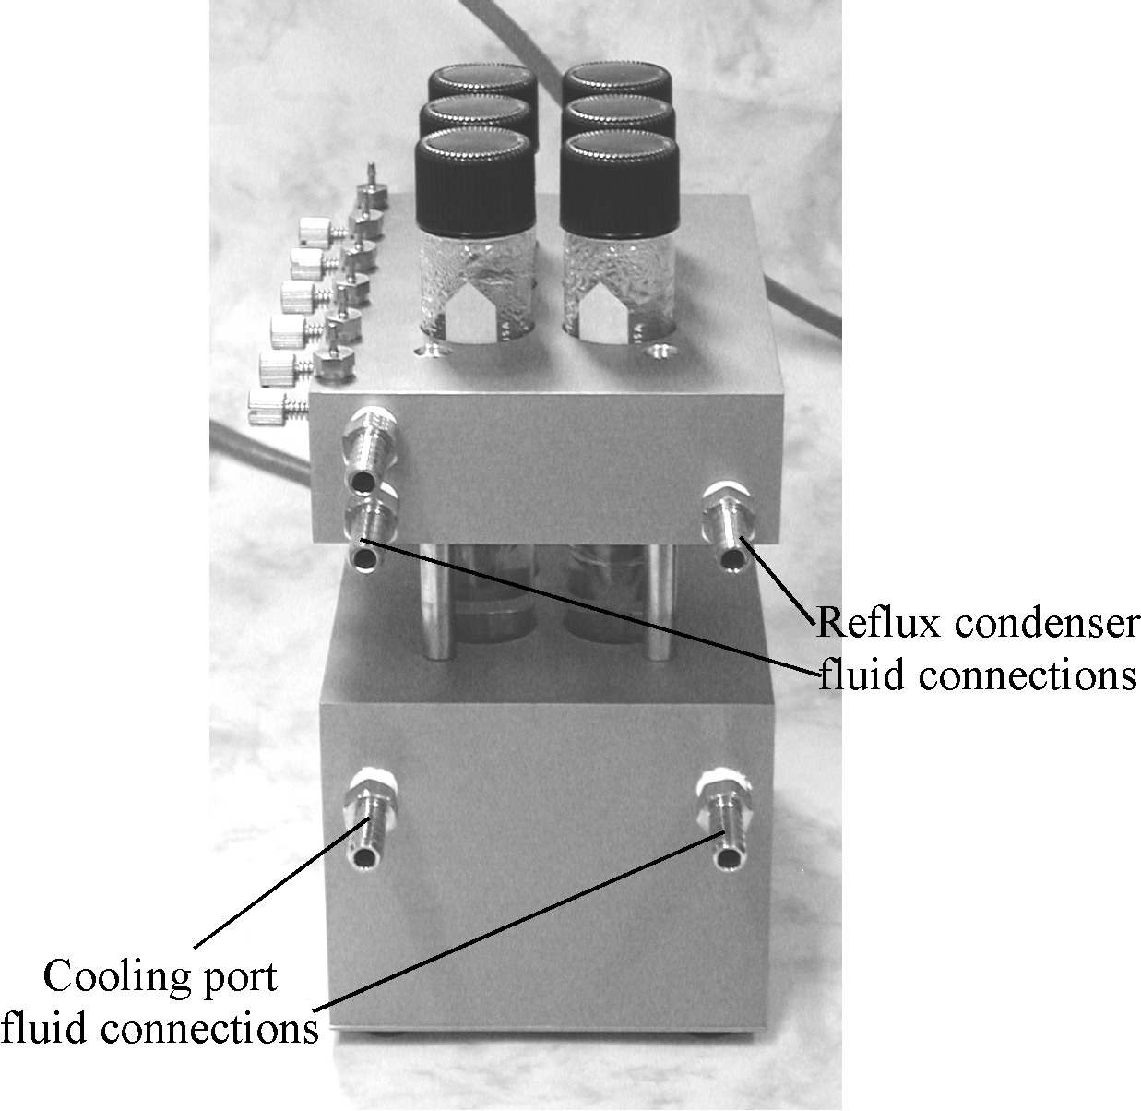 | Connect a circulating fluid to the reflux condenser (tap water) as a source of cooling when running reactions at reflux temperatures.  Cooling of the personal reaction station comes from an external cooling source such as a circulating chiller. Connect the chillers fluid lines to either cooling port on the bottom of the reactor. (J-KEM offers three chillers designed for the PRS). The fluid path in the base of the reactor can be used to circulate both heating or cooling fluids.

Inert Gas Connector

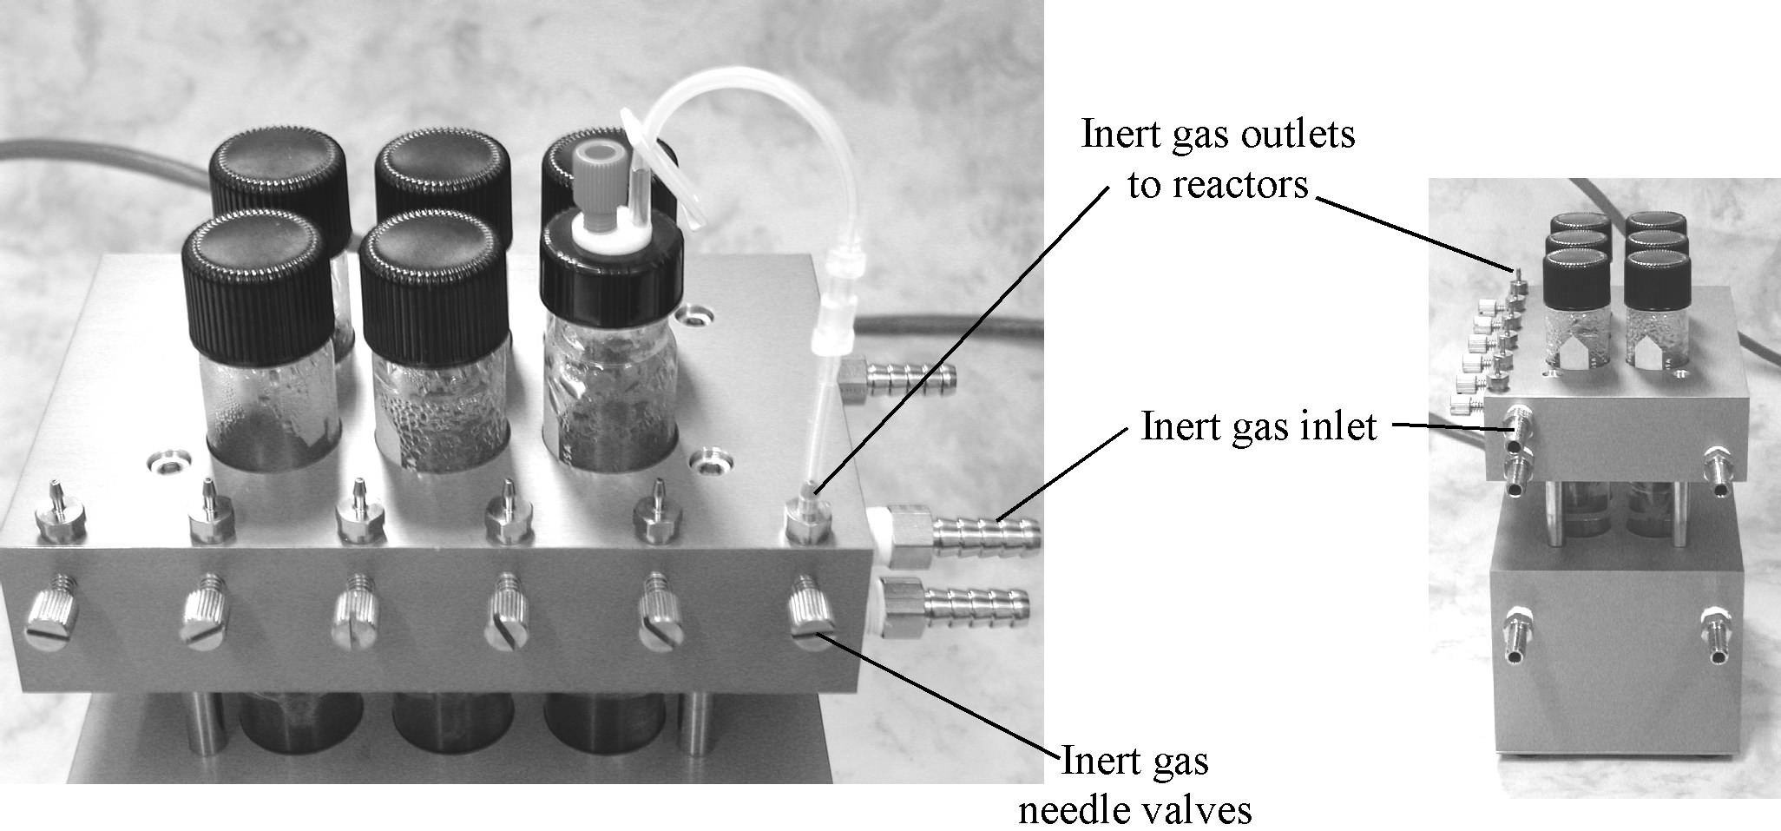

There is no pressure regulation of the inert gas on the personal reaction station and so the researcher must take measures to keep the inlet pressure of the inert gas below 3 psi. An oil bubbler on the inlet side of the inert gas connection is recommended.

Connect the inert gas inlet to a source of inert gas. To place a reactor under inert gas, completely close the needle valve connected to the reactor, then open the needle valve between ½ to 1 full turn.

Septum Replacement

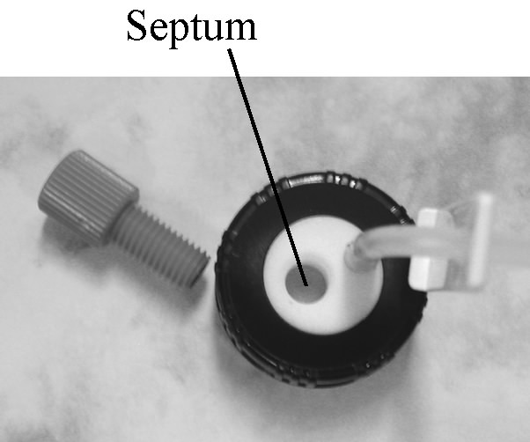 | To replace a septum, remove the red threaded nut to expose the septum. Turn the Teflon plug over, and from the bottom use a paper clip or other rigid item to push the septum out of the plug. Insert a new septum with the white Teflon face down and replace the red nut.

Heating Applications

Set up the reaction in the glass tube. Connect the reaction tubes inert gas line to the reactors inert gas manifold using the quick connect fittings, then open the needle valve for that reactor position ½ to 1 turn counter clockwise. Enter the desired reaction temperature into the controllers digital meter. If reactions temperatures might cause volatilization of the reaction solvent or reactants, cooling water should be circulated through the reactors reflux condenser. The magnetic stirrers are rated for continuous use up to the reactors maximum temperature of 130º C.

Cooling Applications

Set up the reaction in the glass tube. Connect the reaction tubes inert gas line to the reactors inert gas manifold using the quick connect fittings, then open the needle valve for that reactor position ½ to 1 turn counter clockwise. Cooling is provided by an external cooling sources such as a circulating chiller. J-KEM offers three circulating chiller designed for use with the personal reaction station. The magnetic stirrers can be used during cooling applications, but are vulnerable to ice build up at low temperatures which will cause the stirrers to stop operating. In most cases the magnetic stirrers will function at temperatures as low as -40º C, but care should be taken to periodically monitor the stirrers. If the magnetic stirrers stop stirring, then the stirring motors should be turned off by turning the stirring speed knob fully counter clockwise.

Safety Notices: The Personal Reaction Station is not designed to be exposed to elevated pressures or vacuums. Do not pressurize or evacuate the Personal Reaction Station reactors.

Block and Solution Temperature Sensors

The Personal Reaction Station provides two methods to measure and regulate reaction temperatures, the block sensor method and the solution sensor method. The block method uses a temperature sensor built into the aluminum block to sense and regulate the block temperature. The solution method uses an optional Pt/100 temperature probe manually placed in one of the reaction tubes to sense and regulate the solution temperature.

Selecting Between the Block and Solution Sensors
It is critically important that the toggle switch on the back of the controller be set to the method of temperature control you plan to use.
Block (Internal) Temperature Sensor  To control the temperature of the block using the sensor built into the base of the reactor, set the toggle switch on the back of the controller to the “Internal” position. For block control, no sensor should be plugged into the white external connector on the lower left corner of the controller. | 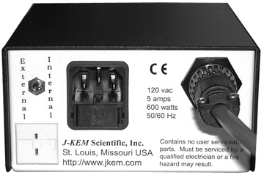
Solution (External) Temperature Sensor  To control the temperature of the solution using an external sensor placed in one of the reactor tubes, set the toggle switch to the “External” position and insert the plug of the external sensor into the white receptacle on the back of the controller.  NOTE: You MUST use a Pt/100 RTD probe as the external sensor, or incorrect temperatures will be displayed and unpredictable temperature control will result. | 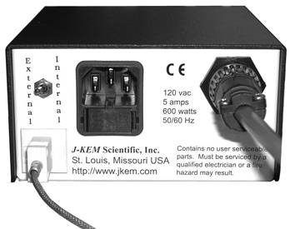

The display of the controller indicates the position of the sensor selection switch when it is initially powered up or when the switch position is changed. When the controller is powered up if the sensor selection switch is set to block (internal) temperature sensor the message “Int” “Rdy” is displayed to indicate that the internal sensor is ready. If the switch is set to the solution (external) position, the message “out” “Rdy” is displayed. If the position of the sensor selection switch is changed while the controller is powered, the appropriate message is displayed to acknowledge the change in temperature sensor selected.
Reaction Temperature Accuracy and Homogeneity

The Personal Reaction Station uses a single temperature sensor to regulate the temperature of six reaction positions. Two issues need to be considered. 1) How accurately does the temperature displayed by the controller reflect the solution temperature, and 2) since there is only a single sensor that measures a single temperature point, how uniform are the six reaction temperatures when compared one to the other. The issues of temperature accuracy and homogeneity are considered for both the Block and Solution sensor methods below.

Block (Internal) Sensor Method
Imbedded in the base of the Personal Reaction Station (PRS) is a temperature sensor that provides the feedback needed to measure and regulate temperatures for the PRS. This sensor is automatically connected to the temperature controller when the gray cord connecting the temperature controller to the block is plugged in. It’s important to understand that when using this sensor, the temperature of the block is directly regulated while the temperature of the solutions in the tubes are indirectly regulated. The advantage of using the blocks’ sensor is the simplicity it provides for reaction setup, all you need to do is connect the gray cord between the temperature controller and the reactor. A possible disadvantage of using the sensor imbedded in the block is the concern of how accurately the block temperature represents the solution temperature.

Temperature Homogeneity Temperature homogeneity in the PRS is excellent, with less than 0.7º C variation between the six reactors at 100º C. Similar results are obtained at any setpoint temperature, reactor volume, or whether using an internal or external sensor.

[Maximum variation between reaction positions ≈ 0.7º C]

Temperature Accuracy When the temperature sensor in the block is used (i.e., the internal sensor), the controller regulates the temperature of the reactor base, but that raises the concern as to whether there is a difference in temperature between the reactor base and the solution temperature. An examination of the two tables below shows that the solution temperature is offset from the block temperature and that a pattern develops with two pronounced characteristics.
1. The greater the volume in the reactor, the greater the offset between the block temperature and the solution temperature. The table shows the deviation from setpoint when toluene is heated to 100º C. With a volume of 5ml, the average offset between the block and solution temperature is 0.9º C , when the volume is increased to 25ml the offset increases to 6.4º C.
The reason for the increasing offset is that as volume increases, the height of the solvent column above the walls of the heated block increase giving rise to greater rates of irradiative heat loss. Also, the heated solvent beings to approach the cooled reflux plate which draws heat from the solution.

2. The second characteristic is that the higher the temperature of the block, the greater the temperature offset of the solution. For example using 15ml of toluene, at a setpoint of 50º C, the solution temperature is offset by 1.1º C, at 100º C, the offset rose to 3.9º C.
[Average deviation from setpoint at 50º C = 1.1º C; at 75º C = 2.8º C; at 100º C = 3.9º C]
Solution (External) Sensor Method

The external probe used with this controller is available through J-KEM which must be a Pt/100 RTD probe using the European resistance curve. The controller will not function properly if a thermocouple is plugged into the external probe input.

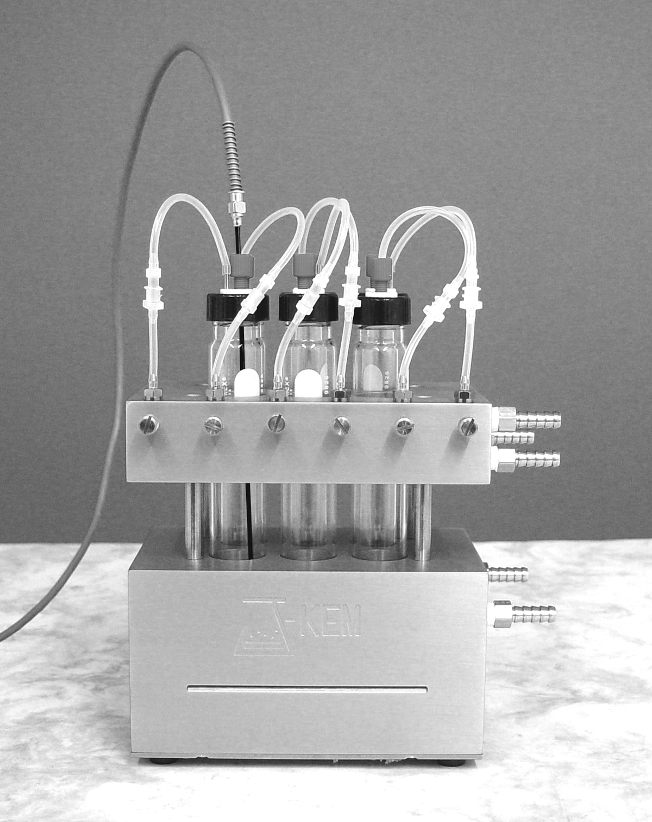 | In addition to regulating the temperature of the reactor, the Personal Reaction Station can sense and regulate the actual solution temperature. In this configuration, an external Pt/100 temperature probe is plugged into the receptacle on the back of the controller and then the probe is placed into the solution of one of the reaction tubes. The advantage of this method is that the solution temperature is directly regulated so that the temperature displayed by the controller is the actual solution temperature. The only disadvantage is that since the external sensor is secured into the tube using it’s septum port, the port of that particular tube can not be used for reagent additions.  The charts below show that when an external temperature probe is used, the temperature of the solutions are precisely regulated independent of reaction temperature or reactor volume.

Instructions for placing the probe in solution.
1) Select the reaction tube to place the probe into (all reactors produce the same result).
2) Remove the fitting and septum from the Teflon plug.
3) Place the fitting over the probe, then slide an O-ring onto the probe, below the fitting.
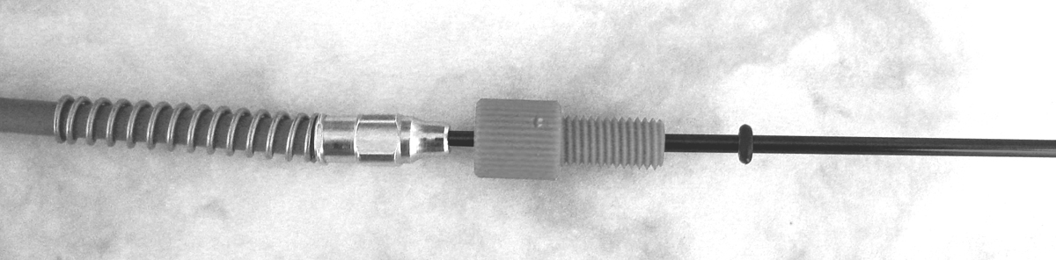

4) Place the probe through the hole vacated by the septum and tighten the probe into the septum fitting.
5) Place the Teflon plug back in the reaction tube and tighten the cap.


Serial Communications.
Communications with, and remote control of the controller is possible using the RS-232 serial port on the back of the controller. Communication protocol is:
Baud – 9600, 8 data bits, 1 stop bit, no parity, no handshaking.
All commands are case sensitive.

Communications Protocol for Dual RS-232 Serial Board
Command | Reply
T(address)\r  Example: T(46)\r | 45.0\r  The reply is the current sensed temperature.
P(address)\r  Example: P(46)\R | 20.0\R  The reply is the current setpoint temperature.
S(address, setpoint)\r  Example: S(46,85.5)\r | OK\r  The reply is simply OK
?(address)\r  Example: ?(30)\r | PRS-120R. F051804-2\r  The reply is a string identifying the controller and the software version.

