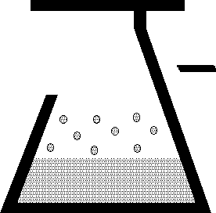 | KEM Scientific, Inc.  Instruments for Science from Scientists | J-KEM® Scientific, Inc.  6970 Olive Blvd.  St. Louis, MO 63130  (314) 863-5536  Fax (314) 863-6070  E-Mail: jkem911@jkem.com

Miniature Overhead Stirrer

Warranty
J-KEM Scientific, Inc. warrants this unit to be free of defects in materials and workmanship and to give satisfactory service for a period of 12 months from date of purchase. If the unit should malfunction, it must be returned to the factory for evaluation. If the unit is found to be defective upon examination by J-KEM, it will be repaired or replaced at no charge. However, this WARRANTY is VOID if the unit shows evidence of having been tampered with or shows evidence of being damaged as a result of excessive current, heat, moisture, vibration, corrosive materials, or misuse. This WARRANTY is VOID if devices other than the reaction block supplied with this unit are powered by the controller. Components which wear or are damaged by misuse are not warranted. This includes contact points, fuses and solid state relays.
THERE ARE NO WARRANTIES EXCEPT AS STATED HEREIN. THERE ARE NO OTHER WARRANTIES, EXPRESSED OR IMPLIED, INCLUDING BUT NOT LIMITED TO THE IMPLIED WARRANTIES OF MERCHANTABILITY AND OF FITNESS FOR A PARTICULAR PURPOSE. IN NO EVENT SHALL J-KEM SCIENTIFIC, INC. BE LIABLE FOR CONSEQUENTIAL, INCIDENTAL OR SPECIAL DAMAGES. THE BUYER'S SOLE REMEDY FOR ANY BREACH OF THIS AGREEMENT BY J-KEM SCIENTIFIC, INC. OR ANY BREACH OF ANY WARRANTY BY J-KEM SCIENTIFIC, INC. SHALL NOT EXCEED THE PURCHASE PRICE PAID BY THE PURCHASER TO J-KEM SCIENTIFIC, INC. FOR THE UNIT OR UNITS OF EQUIPMENT DIRECTLY AFFECTED BY SUCH BREACH.

J-KEM Scientific, Inc.  858 Hodiamont Ave.  St. Louis, MO 63112  USA | Phone: (314) 863-5536  FAX: (314) 863-6070  Web site: http://www.jkem.com  E-Mail: jkem911@jkem.com

Safety Notices

Solvents and Vapors
J-KEM’s Overhead Stirrer should not be used in an environment with explosive levels of flammable gas vapors.
CAUTION: Only qualified personnel knowledgeable in laboratory procedures should use this equipment..

Symbols
Power Switch: 1 - Mains power (110-240vac) is ON 0 - Mains power (110-240vac) is OFF

General Notice
WARNING: If stirrer is not used as specified in this manual, the protection provided may be impaired.

Stability
The Overhead Stirrer is equipped with a back-mounting clamp. The stirrer should not be clamped to a free standing ring stand that can tip over. The Stirrer should only be clamped to lattice networks securely attached to a bench or laboratory hood.

Power
Voltage: 110-240 VAC @ 50-60Hz
Wattage: 240 watts maximum; Peak 2 amps
Fusing: 2 amp fast acting (F) 240 Vac.

Environmental
Indoor use. Operating temperatures of 5o C to 40o C. Maximum relative humidity of 80%.
Installation category II

Setup  The overhead stirrer consist of two parts, a high torque, low voltage motor and a digital speed controller. The microprocessor of the speed controller maintains a constant stirring rate under varying torque conditions. The controller monitors speed and power applied to the motor and can detect an over-current or stall condition. A safety feature of the controller removes power from the motor when an over-current or motor stall condition is detected.  1. Secure the support rod of the motor to an appropriate lattice support rack. Secure the motor to the same lattice, close to the motor.  2. Connect the gray cord coming from the motor to the round black connector on the side of the speed controller. The motor is powered by a variable DC voltage, at maximum RPM and torque, the output voltage does not exceed 13.5 Vdc.  Connect the power cord to the digital controller (Input voltage: 110 – 240 Vac). | 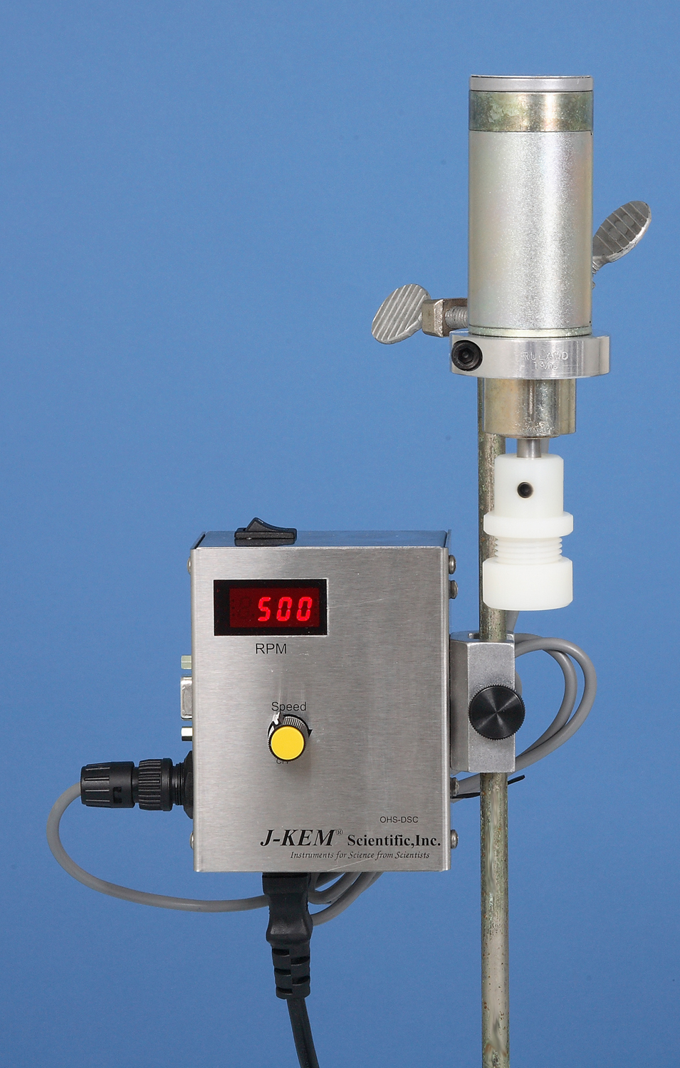
3. Insert a 10mm OD glass or stainless steel stirring rod though the plastic stirring rod adapter, then insert the rod and adapter into the chuck of the motor. Tighten the chuck with finger-tight pressure.  4. Align the stirring rod with the vessel being stirred.  5. Turn power to the controller on and adjust the stirring speed using the speed control pot on the front of the controller. The digital readout continuously displays the actual speed of the stirrer in units of Rotations Per Minute. In the event of system errors, the digital readout displays appropriate error messages (see later). |  | 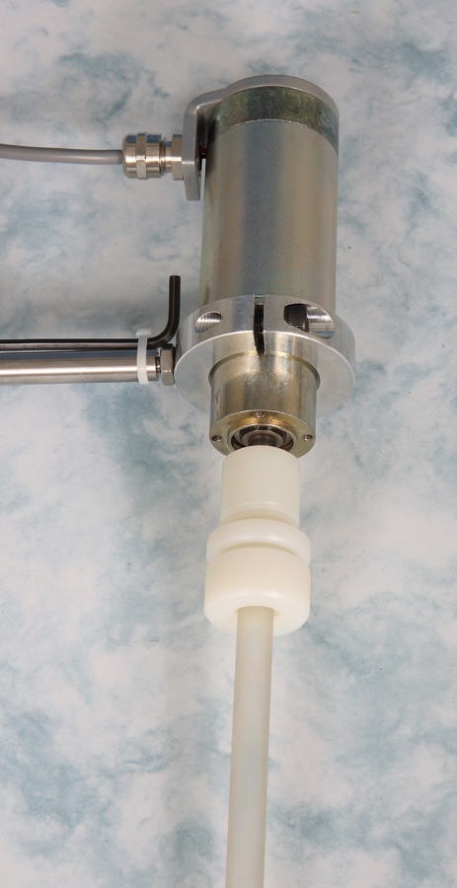

PC Control and Data Logging

J-KEM’s Overhead Stirrer has built-in serial communications for PC control and data logging. The implemented commands and communication protocol is presented later in this manual. J-KEM also offers KEM-RPM, graphical Windows software, to create programmable stirring profiles and to log to the PC run data, including time, torque, and speed of the Overhead Stirrer.

External Control.
The Overhead Stirrer (OHS) can be operated remotely, either by means of serial communications (see later), or stirring can be turned On/Off by means of a mechanical contact.

Stirring by the OHS can be turned On/Off by means of an external contact. Setup the unit as normal, then adjust stirring to the desired speed using the front panel speed control.
Connecting Pin 1 to Pin 5 on the DB9 connector causes the stirrer to stop and the controller to show ‘StOP’ in the display. Releasing this connection causes the controller to resume stirring at the rate set by the front panel control. Do not connect an external voltage to Pins 1 or 5. The only acceptable connection to these pins is either a mechanical contact closure or an electronic connection that pulls pin 1 down to the level of Pin 5 where Pin 5 is ground (i.e., open collector output to Pin 1 or similar circuit). Contact J-KEM for assistance.
Shown are acceptable circuits to operate the external Start/Stop circuit of the controller.

Overhead Stirrer Display Messages

The LED display of the controller normally displays the speed of the stirrer, but also displays other messages depending on the run conditions. The meaning of each display is listed below.

Display | Description
100 - 800 | This is the normal display of the OHS. This shows the current rotational speed of the stirrer in units of RPM.
P100 - P800 | When the controller is operated by serial commands from the RS232 serial port, the display shows the letter ‘P’ as the first character.  This display shows that the controller is under external control, and then the rotational speed of the motor in units of RPM.
StOP | The OHS controller is stopped by hardware. Pin #1 (Run/Stop) is connected to pin #5 (Ground) in the RS232 connector. This hardware control has the highest priority and it will take precedence over the speed control knob and ASCII commands.
off | The OHS motor is off.
Poff | The OHS motor is off and the OHS is under PC or external controller control.
o-Ld | The OHS is overloaded. The controller shows this message when it’s unable to reach the specified speed (RPMs) due to power limitations. Under this condition the controller reduces its speed to a value where it can run permanently without over heating.
oPEn | The OHS motor terminals are open circuit.  The controller shows this message when:  - The motor is unplugged from the OHS controller  - There’s a cut wire, bad connector terminal, or bad motor.
StAL | The OHS motor is stalled or there’s an over current condition.  The controller shows this message when:  - The motor’s shaft is stalled  - Excessive motor current consumption  - Short circuit in motor, motor’s cable or motor’s connector
bPot | The OHS speed control knob is not working properly.  The controller shows this message when:  - The potentiometer is defective  - There’s an open connection between the potentiometer and the control board.

Communication Interface

The communication between the PC (or controller) and the OHS (Overhead Stirrer Controller) is serial RS232 - 9600,8,N,1 (default configuration settings when initially powered up).
Of these settings, only the baud rate can changed by issuing the “BR” command.
The serial connection uses a straight-through DB9 serial cable from PC to controller.

Protocol Syntax

Command Format: <Command><Value><CR>
Command: SS350<CR> Reply: SS350<CR>
Sets the motor speed to 350 RPM.

Query Format: <Command><CR>
Query: SS<CR> Reply: SS250<CR>
Returns the current running speed in RPM.
NOTE: Each command lists whether it accept commands, queries, or both.

Error Format: <Command><Value><CR>
Example: FAST<CR> (non-existing command)
If the command doesn’t exist or it’s out of range the reply will be:
BadCmd<CR>

<Command> is a two bytes command, upper case letters only.
<Value> is a float or unsigned integer value. See each particular command for the acceptable range.
<CR> stand for "Carriage Return", or 0x13.

Command | Value (range) | Query\Command | Description
SS | 0 (OFF)  20-800 (RUN) | Q/C | Sets/ Reads the OHS motor speed in RPM.  A value of zero turns off the motor. See “display messages” section.  When the OHS is under PC or external control, the display shows the letter “P” in the first digit.  NOTE: If you set the speed of the motor via serial command, the OHS disables the speed knob and ignores any manual adjustment of the potentiometer. Use the “RM” command to release the controller from PC control. Be aware that after issuing the “RM” command, the controller adjusts the motor speed to the value determined by the speed pots position.
TQ | None | Q | Returns the torque sensed by the OHS motor in units of oz-in.  NOTE: Even when the OHS is running with no load, this command returns a value greater than zero. This represents the motor and gearbox’s internal friction.
CU | None | Q | Returns the actual OHS current consumption in Amperes.
VL | None | Q | Returns the actual voltage applied to the OHS motor in Volts DC.

RM | None | C | This command releases the OHS device from PC or external control. Read “SS” for more details.  NOTE: Be aware that after issuing the “RM” command, the controller adjusts the motor speed to the value determined by the speed pots position.
PI | None | Q | This command returns a string containing product information, software version, and date of manufacture.  Example: OHS-DSC v2.0-080609\r
MS | None | Q | This command returns the OHS status  Where:  MS0 = OHS normal operation  MS1 = OHS overloaded  MS2 = OHS stalled/excessive current consumption  MS3 = OHS terminal open  MS4 = OHS stopped by hardware (RS232 pin 1 to ground)  NOTE:  See “display messages” for more details.
BR | 0-5 | Q/C | This command sets/reads the baud rate of the serial port.  Where:  BR0 = 2400 bps  BR1 = 4800 bps  BR2 = 9600 bps  BR3 = 19200 bps  BR4 = 38400 bps  BR5 = 57600 bps  NOTE:  After changing the baud rate, and the controller returns confirmation of the command, you must wait 20 mSec before communicating at the new speed.  Every time the controller is turned on, the controller initiates communicates at its default speed of 9600 bps.

