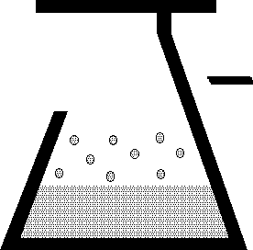 | KEM Scientific, Inc.  Instruments for Science from Scientists | J-KEM® Scientific, Inc.  6970 Olive Blvd.  St. Louis, MO 63130  (314) 863-5536  Fax (314) 863-6070  E-Mail: jkem911@jkem.com

Nitrogen Gas Heater

Warranty
J-KEM Scientific, Inc. warrants this unit to be free of defects in materials and workmanship and to give satisfactory service for a period of 12 months from date of purchase. If the unit should malfunction, it must be returned to the factory for evaluation. If the unit is found to be defective upon examination by J-KEM, it will be repaired or replaced at no charge. However, this WARRANTY is VOID if the unit shows evidence of having been tampered with or shows evidence of being damaged as a result of excessive current, heat, moisture, vibration, corrosive materials, or misuse. This WARRANTY is VOID if devices other than the reaction block supplied with this unit are powered by the controller. Components which wear or are damaged by misuse are not warranted. This includes contact points, fuses and solid state relays.
THERE ARE NO WARRANTIES EXCEPT AS STATED HEREIN. THERE ARE NO OTHER WARRANTIES, EXPRESSED OR IMPLIED, INCLUDING BUT NOT LIMITED TO THE IMPLIED WARRANTIES OF MERCHANTABILITY AND OF FITNESS FOR A PARTICULAR PURPOSE. IN NO EVENT SHALL J-KEM SCIENTIFIC, INC. BE LIABLE FOR CONSEQUENTIAL, INCIDENTAL OR SPECIAL DAMAGES. THE BUYER'S SOLE REMEDY FOR ANY BREACH OF THIS AGREEMENT BY J-KEM SCIENTIFIC, INC. OR ANY BREACH OF ANY WARRANTY BY J-KEM SCIENTIFIC, INC. SHALL NOT EXCEED THE PURCHASE PRICE PAID BY THE PURCHASER TO J-KEM SCIENTIFIC, INC. FOR THE UNIT OR UNITS OF EQUIPMENT DIRECTLY AFFECTED BY SUCH BREACH.

J-KEM Scientific, Inc.  858 Hodiamont Ave.  St. Louis, MO 63112  USA | Phone: (314) 863-5536  FAX: (314) 863-6070  Web site: http://www.jkem.com  E-Mail: jkem911@jkem.com
Safety Notices

Solvents and Vapors

J-KEM’s Nitrogen gas heater must not be used in an environment containing flammable organic reagents or gas vapors. Any inert gas can be used with the gas heater, such as nitrogen or argon. No flammable reagents of any nature or reactive gasses, such as oxygen, can be used with this heater.
CAUTION: This equipment should only be operated by qualified personnel knowledgeable in laboratory procedures.

Symbols

Power Switch: 1 - Mains power (120vac) is ON
0 - Mains power (120vac) is OFF

 | Caution. Risk  of electric  shock. |  | Caution. No  user serviceable  parts. |  | Protective conductor terminal. Earth Ground.

General Notice

WARNING: If equipment is not used as specified in this manual, the protection provided by this equipment may be impaired.

CAUTION: When operating this equipment insure that the heater is located away from flammable object.

Power

Voltage: 120 VAC @ 50-60Hz
Wattage: 600 watts; 5 amps.
Fusing: 5 amps

Environmental

Indoor use
Altitude up to 2000 meters
Operating temperatures of 5o C to 800o C
Operating pressure: Maximum outlet pressure is 5 psi
Maximum relative humidity of 80% for temperature up to 31o C decreasing linearly to 50% relative humidity at 40o C.
Installation category II
Controller Description
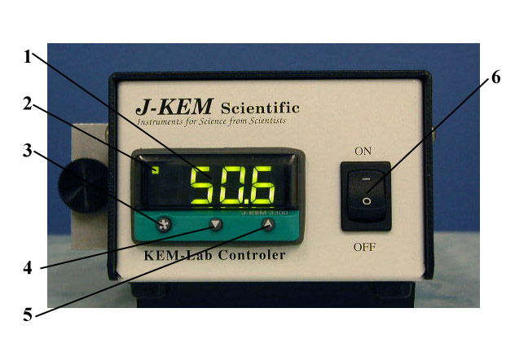
1. Temperature Display. Shows temperature of the exit gas as the default display. Shows set point temperature (i.e. desired temperature) as a blinking number when ‘*’ button is held in.

2. Indicates that heating power is being applied to the heater when lit.

3. Control Key. When held in, the display shows the set point temperature. To decrease or increase the set point, press the ‘t’ key (4) or ‘s’ key (5), while simultaneously holding in the control key. The set point appears as a blinking number in the display.

4. Lowers set point when ‘*’ button (3) is simultaneously pressed.

5. Raises set point when ‘*’ button (3) is simultaneously pressed.

6. Controller On/Off switch.

Connecting Gas to the Gas Heater

The gas heater has a gas inlet and outlet with no other connections. Connect inlet gas to the port labeled IN which is the port on the same side of the heater that the power cord from the temperature controller connects to. The heated gas outlet is on the side of the controller labeled OUT. The outlet of the heater must be at atmospheric pressure, the heater core pressure must not exceed 5 PSI.

Before turning the temperature controller on, the gas heater MUST:
1. Have gas entering on the port labeled “IN” and exiting on the port labeled “OUT”, and
2. nitrogen gas must be flowing through the heater at a minimum flow rate of 1 liter per minute.
Failure at either of these points will burn the heater out and void the warranty..

Entering a Setpoint into the Controller

1. Turn on gas flow into the heater to a minimum flow rate of 1000ml/min.

2. Turn power on to the digital temperature controller. The default display (when no buttons are being pressed) of the controller is the current oven temperature.

3. To see the current setpoint temperature
(i.e., the desired temperature), press
and hold in the ‘*’ button on the front of the digital meter. The current setpoint appears as a blinking number in the display. To enter a new setpoint, hold in the ‘*’ button on the front of the meter. While holding in the ‘*’ button press either the s button to increase, or the t button to decrease the setpoint. When the desired temperature is present in the display, release all the buttons.

Use with J-KEM’s KEM-Vap Vacuum Controller

The nitrogen gas heater is not compatible with J-KEM Scientific’s KEM-Vap Infinity Controller Vacuum Regulator. Under no circumstance should the two units be used with one another. Using the gas heater with the KEM-Vap controller will result in an unsafe operating condition, will burn out the gas heater, and will result in the warranties of both units being voided.

