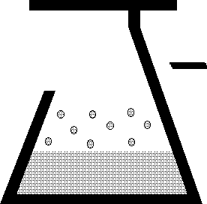 | KEM Scientific, Inc.  Instruments for Science from Scientists | J-KEM® Scientific, Inc.  858 Hodiamont Ave.  St. Louis, MO 63112  (314) 863-5536  Fax (314) 863-6070  E-Mail: jkem911@jkem.com

Precision Vacuum Controller, DVR-1000

J-KEM Scientific’s precision vacuum and pressure regulators consist of J-KEM’s Infinity-II pressure sensor/controller and KEM-Torr software that presents a graphical user interface to the Infinity controller. KEM-Torr software displays the system pressure in real-time both graphically and with a digital display, allows the user to construct and run a 12-step pressure ramp, and optionally data logs time, pressure and ramping history.

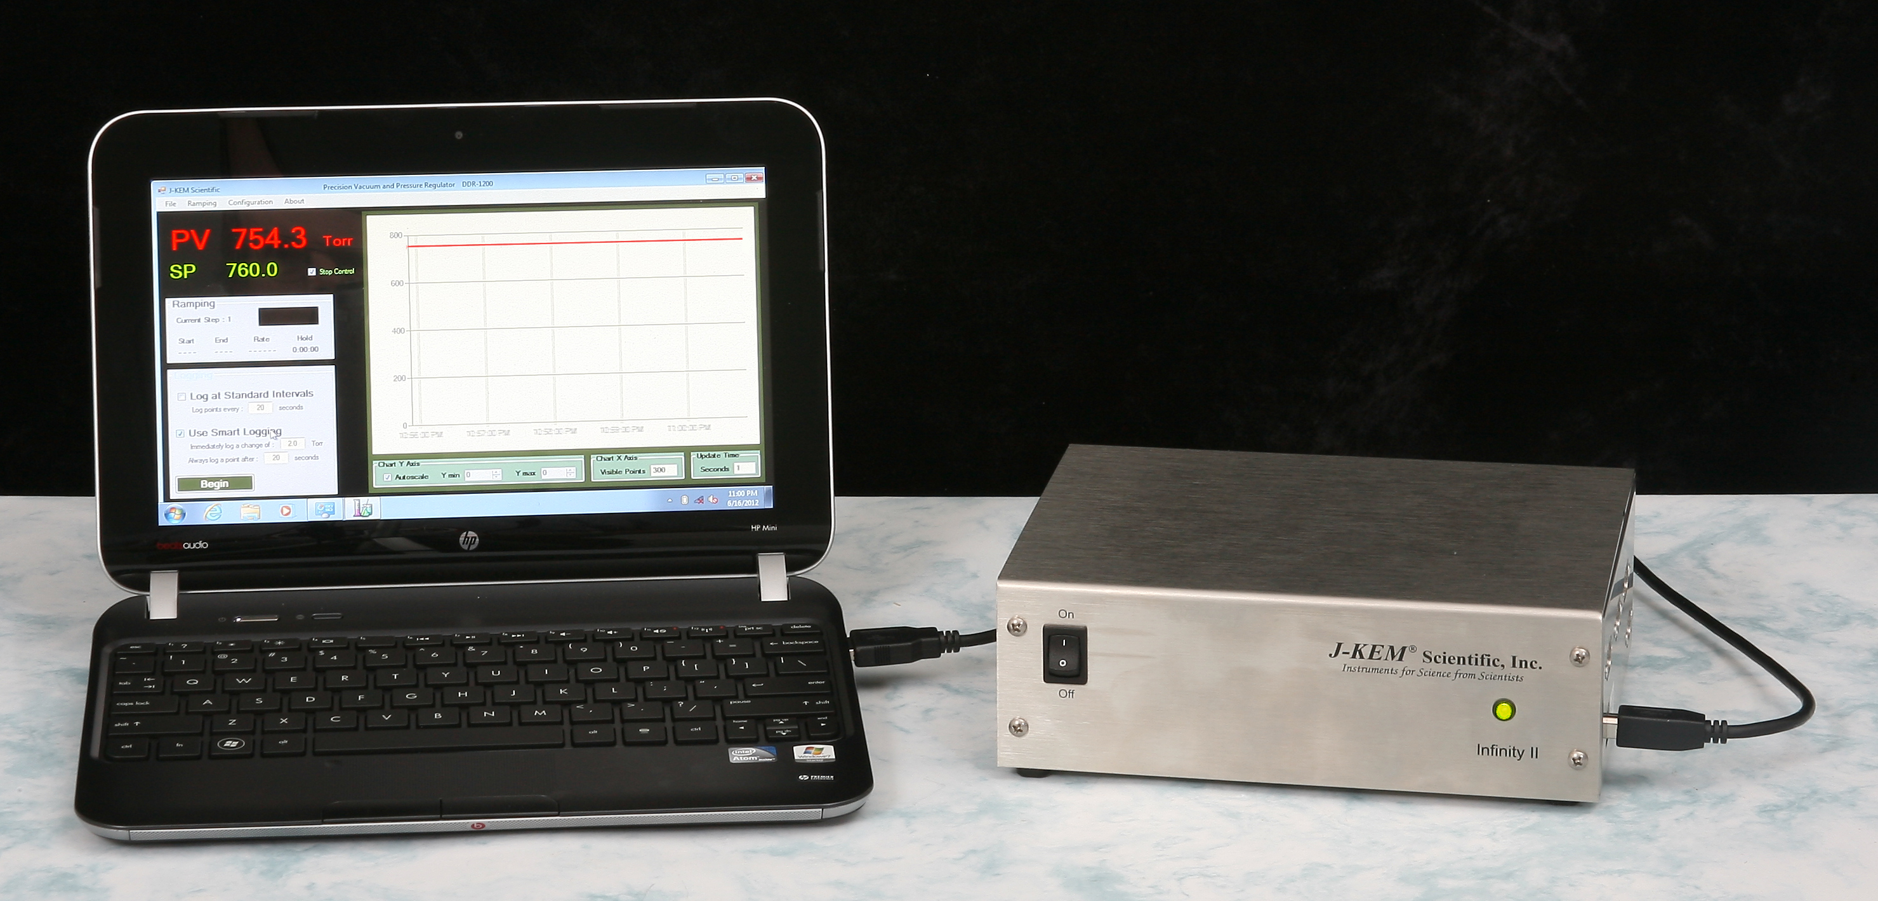

Software Installation
Systems With a PC Controller Pressure regulators ordered with the companion Netbook controller, have KEM-Torr software pre-loaded and no other software setup is required.

System Without a PC Controller KEM-Torr software, PC drivers, and this user manual are included on a flask disk shipped with the Infinity. Do not connect the Infinity controller to your PC until instructed to do so.
1. To install the KEM-Torr software - Insert the flash disk into your PC, open the folder titled Application Software and then double click on the installation icon titled Setup.exe. During the installation, accept all of the default selections.
2. Copy the user manual on the flash disk to the desk top of your PC.
3. Install the Infinity drivers, by opening the folder titled Infinity Drivers and double clicking on the icon titled Infinity_Setup.exe. Allow Windows to install the drivers, and in the process accept all of the default settings.
Hardware Setup for an Evacuation Only (single valve) Controller

NOTE: The pressure proportioning valve is very sensitive to contaminates that cause the valve to stick. A high efficiency trap must be placed between the proportioning valve and the reaction system to protect the valve. Proportioning valves are not warranted against failure.

1. Connect the outlet of the vacuum proportioning valve to the vacuum source. The vacuum valve will be one of two types. It will either have a silver coil on top of a silver body (PSV2 - PSV5 valves), or a silver coil on top of a black body (PSV6 – PSV 8 valves). If the valve has a silver body, note that the cylindrical portion of the valve is offset from the square body of the valve, connect the fitting closest to the cylinder to the vacuum source. Connect the other fitting to the outlet of a dry ice trap. If the valve has a black body, connect the port labeled “OUT” to the vacuum source and the port labeled “IN” to the dry ice trap.

2. Plug the proportioning valve’s gray cord into the electrical connector on the back of the Infinity regulator labeled “Vacuum”. Make sure the cable locks into position.

3. Connect the vacuum sensing inlet on the back of the Infinity regulator (a threaded or Swagelok fitting) to a Tee connector between the inlet of the trap and the piece of equipment that pressure is being regulated in. Wide bore tubing should be used to make all pressure connections. The length of tubing between the Infinity regulator’s vacuum sensing inlet and the reactor under vacuum should be kept to a minimum (no longer than 6 feet, but under 3 feet will yield more accurate results). To set up the regulator, simply connect a USB cord between the Infinity-II regulator and the Netbook PC controller.
Hardware Setup for a Dual Control (dual valve) Controller

NOTE: The vacuum and atmosphere proportioning valves are very sensitive to contaminates which cause the valves to stick. A high efficiency trap must be placed between the vacuum proportioning valve and the reaction system to protect the valve. Proportioning valves are not warranted against failure.

1. Connect the outlet of the vacuum proportioning valve to the vacuum source. The vacuum valve will be one of two types. It will either have a silver coil on top of a silver body (PSV2 - PSV5 valves), or a silver coil on top of a black body (PSV6 – PSV 8 valves). If the valve has a silver body, note that the cylindrical portion of the valve is offset from the square body of the valve, connect the fitting closest to the cylinder to the vacuum source. Connect the other fitting to the outlet of a dry ice trap. If the valve has a black body, connect the port labeled “OUT” to the vacuum source and the port labeled “IN” to the dry ice trap.

2. Plug the vacuum proportioning valves gray cord into the electrical connector on the back of the Infinity regulator labeled “Vacuum”. Make sure the cable locks into position.

3. Plumb the back-fill proportioning valve into the system as shown. If the system uses a silver PSV2 –PSV5 valve, then leave the fitting that is furthest from the top coil open to atmospheric pressure (see drawing above). If the uses a PSV6 –PSV8 valve, then leave the port labeled “IN” open to the air.

4. Plug the back-fill proportioning valves gray cord into the electrical connector on the back of the Infinity regulator labeled “Pressure”. Make sure the cable locks into position.

5. Make the other gas connections shown in the drawing above. Wide bore tubing should be used to make all pressure connections. The length of tubing between the Infinity controller’s pressure sensing inlet and the reactor under control should be kept to a minimum (no longer than 6 feet, but under 3 feet will yield more accurate results).
Software Setup

1. Connect a USB cable between the Infinity-II regulator and the Netbook PC controller. Turn on power to the Infinity before starting the KEM-Torr software.
2 Start the KEM-Torr software by double clicking on the KEM-Torr icon on the controller’s desktop.

The software displays the sensed pressure and immediately begins to plot data. Note that pressures are displayed as ‘Absolute’ pressure.

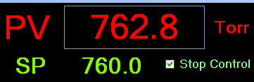 | The pressure sensed by the regulator is continuously updated and displayed as the PV value in red.
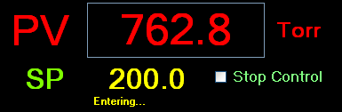 | To enter a setpoint (i.e., the target pressure to regulate the connected system to), place the cursor inside the green setpoint pressure value (i.e., “760.0”) and type the desired value. then hit the Enter (Return) key on the keypad. While the new setpoint is being input, the value turns yellow, when the Return key is hit the new value is entered and the setpoint value turns green again. The regulator begins to operate the vacuum value to evacuate the system until it reaches the setpoint pressure.

Single and Dual Valve Controllers – The standard DVR-1000 is programmed to operate a single evacuation proportioning valve. With only an evacuation valve, the DVR-1000 can decrease pressure in the system under test, but it has no ability to increase pressure. For example, the user can evacuate a chamber to 400 torr and subsequently evacuate it to 100 torr, since the evacuation proportioning valve has the ability to decrease the system pressure. But if the chamber is evacuated to 100 torr, the standard DVR-1000 has no ability to increase the system pressure to 300 torr, since this would require bleeding pressure from the atmosphere into the system under test. J-KEM does offer an optional feature for the DVR-1000 controller that allows it to both evacuate a system and to re-pressurize the system. This optional feature requires both an evacuation proportioning valve (the standard valve) and a second back-fill valve (optional). Also the DVR-1000 must be configured for dual valve operation. When the dual valve option is installed, the DVR-1000 can freely increase and decrease pressure in a system under test. Contact J-KEM for information.
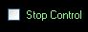 | Any time during a run, vacuum control can be suspended by placing a check mark in the box titled Stop Control. Removing the check mark restarts vacuum regulation. The system pressure is continuously updated whether the regulator is active or not.
Menu Options – The Run-Time menu contains several options pertaining to an active run.
Ramping – Contains the controls needed to create and run a vacuum ramp. See the section titled Entering a Vacuum Ramp Program.
Logging – Contains controls to configure and initiate logging time and pressure data to a *.csv file on the PC. See the section on Logging for detailed information.
Charting – Contains the controls needed to adjust the charting area. See the section titled Charting Controls.
Fast Update – When selected, this option provides faster update of the displayed pressure at the cost of slightly more background noise in the pressure signal.

Menu Options – The Configuration menu has several items that affect the operation of the DVR-1000.
Enable Configuration Menu – The menu items in the Configuration menu are by default, not enabled to pervert accidentally adjusting a parameter that affect the controller in an adverse manner. To enable the items in the Configuration menu, select Enable Configuration Menu.
Display Units – From this menu, the user can select the units that pressure is displayed and entered in. The three common units, PSI, Torr, and Atm are presented in this menu, but other units are available in the Customize menu.
Monitor DAC Output – This displays a window on the main form that shows the amount of voltage applied to the proportioning valve. This is for diagnostic purposes only and provides no useable information to the researcher.
Infinity Configuration – The opens a form that displays the configuration of the various analog inputs on the Infinity controller. From this form the user can recalibrate the controller if needed, see the section titled Vacuum Regulator Configuration and Calibration.
Customize – Allows the user to customize various features of the KEM-Torr software including the units pressures are displayed in, logging defaults and other parameters. See the section titled Customizing the KEM-Torr software.

Entering a Vacuum Ramp Program
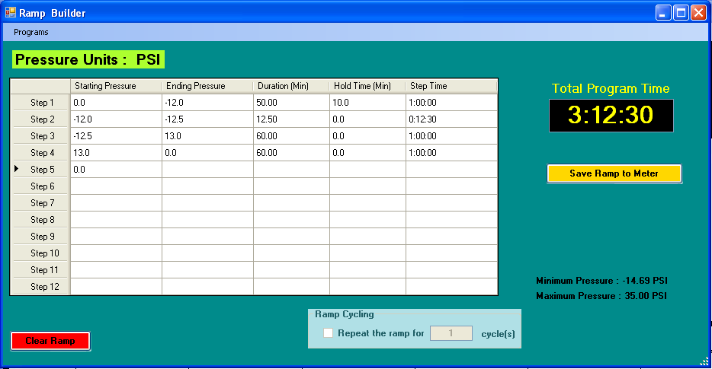 | The ramping functions of the software support a 12 step vacuum ramp. To display the ramp construction form, select Run-Time -> Ramping -> Build Ramp from the Run-Time menu.  Each row in the table is a single ramp step, a ramp step includes both a pressure change segment and a hold segment.  Starting Pressure – This is the setpoint pressure that the ramp step start at.
Ending Pressure – This is the ending setpoint pressure of the ramp step. For controllers with evacuation control only (single valve controllers), the ending pressure must always be lower than the starting pressure. For evacuation and pressure control units (dual valve controllers), the only restriction of starting and ending pressures is the pressure range of the controller.
Duration (min) – This is the amount of time the program takes to ramp from the Starting to the Ending Pressure.
Hold Time – When a ramp segment completes, the user can optionally enter a hold time for the step. During a hold time, the setpoint is held constant at the ending pressure of the ramp. If you do not want a hold, time, enter a value of 0.
Step Time – This column displays the time required to complete the current ramp step.

When a ramp step completes, including the ramp and hold segments, the ramp program immediately continues at the starting setpoint pressure of the next ramp step. The starting setpoint pressure of the subsequent step is always the ending pressure of the previous step.
When a ramp program completes, the controller remains at the ending setpoint pressure of the last step.
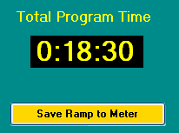 | This box shows the total time required to complete all steps of the ramp program. When the ramp program is completely entered, the program is uploaded to the DVR-1000 by clicking the Save Ramp to Meter button.  To delete an entered ramp, you can click the Clear Ramp button on the bottom of the screen.
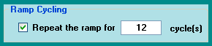 | If the DVR-1000 is equipped with the optional back-fill pressure option, the Ramp Cycling box is enabled. Ramp Cycling allows the ramp program to restart the ramp program as soon as one pass of the program completes. For example, if a
4-step ramp program is entered, ramp cycling resets the ramp to Step 1 as soon as Step 4 completes. The user can enter then number of times the program will repeat (cycle) in the text box provided.

Storing a Ramp Program - Ramp programs can be stored for later recall. To save a program, select Store Program from the Programs menu. You will be prompted to enter a name for the ramp method. Enter a name, then click OK.
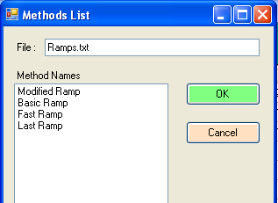 | Recalling a Ramp Program – To load a saved ramp, select Recall Program form the Programs menu. A window appears that lists the names of the saved programs, click on the desired program, then click the OK button.  Deleting a Ramp Program – To delete a save program, select Delete a Saved Program from the Programs menu. From the list of programs that appears, click on the program to delete, then click the OK button.
Running a Ramp Program
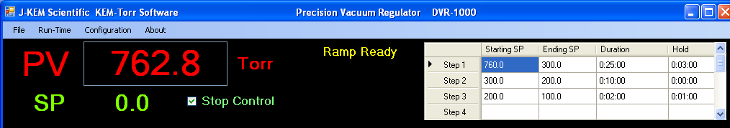 |  | Once a ramp program has been saved to the controller, it appears on the main screen.  Start a Ramp - To start the ramp, select Ramping -> Start Ramp from the Run-Time menu.
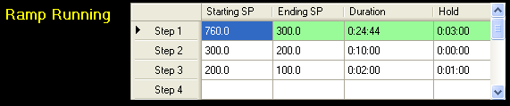 | The current step of a ramp is highlighted in green. During the ramp portion of a program step, the duration time counts down like a digital clock to indicate the time in the ramp remaining. If the program step has a Hold time, then following the completion of the ramp segment, the hold time value begins to count down, indicating the amount of hold time remaining.
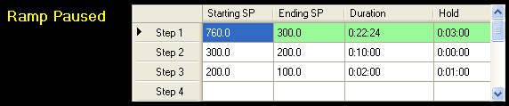 | Pause a Ramp - A running ramp can be paused by selecting Ramping -> Pause Ramp from the Run-Time menu. When a ramp is paused, the clock in either the Duration or Hold table cells stop decrementing. To resume the ramp step, select Ramping -> Resume Ramp from the Run-Time menu.
Advance to Next Step – A ramp can be forced to complete the current step and advance to the next step in the program by selecting Ramping -> Advance to Next Step from the Run-Time menu.

Reset Ramp – When a ramp completes, it can be reset and run again by selecting Ramping -> Reset Ramp from the Run-Time menu. When selected, the ramp is reloaded to the meter. To start the ramp, select Ramping -> Start Ramp.

Abort Ramp – A ramp can be terminated by selecting Ramping -> Abort Ramp from the Run-Time menu.
Charting Controls

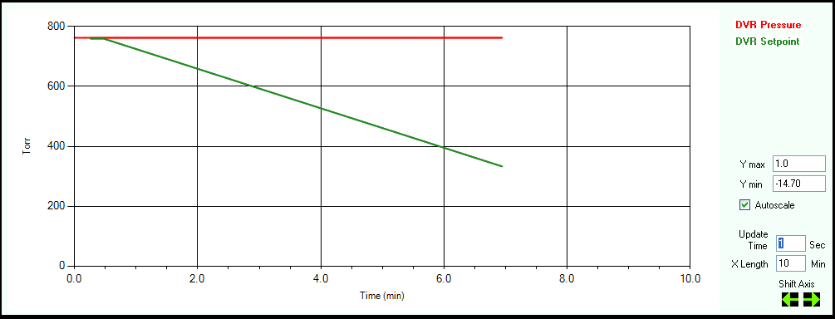
Autoscale - When checked, the graph automatically sets the Y-axis scale to display the plotted data. When unchecked, the user can manually enter the Y-axis minimum and maximum values.

X-Axis Length Sets the length of the X-axis
Update Time Sets the update time of the X-axis and the rate at which data points are collected.

Shift Axis - During normal charting, the axis continuously shifts the X axis so that newly collected points are displayed at the end of the plot. The user can manually shift the displayed plot to view points that have scrawled out of the field of view. Every time the shift left button is clicked, the X plot shifts to older times by the amount specified in the Chart X Axis Length box. Every time the shift right button is clicked, the X plot shifts to newer times by the amount specified in the Chart X Axis Length box. While a plot is shifted left, new points are still logged to the plot, but the plot does not update its view. The view remains static and shows only the section of the chart that has been shifted to. While a charts X-axis is shifted, the back color of the chart changes to light blue.

Menu Options A bit map image of the chart currently displayed can be captured and saved to the PC hard drive. This might be useful for process documentation purposes. To capture the current chart, from the Run-Time menu, select Charting -> Capture Pressure Plot. When this menu option is selected, you are prompted to enter a file name for the plot.

To clear the charting area, select Charting -> Reset. Clearing the charting area only affects the chart, it has not effect on data being logged to a file using the data logging controls.

The setpoint pressure can be plotted on the chart by selecting the option Chart Setpoint Pressure from the Charting menu in the Run-time menu.

Logging Pressure Data
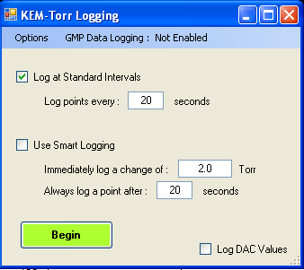 | To start logging process data to disk, select Logging, then Start Logging from the Run-Time menu.  There are two logging methods, 1) Standard Logging, and 2) Smart Logging.  Standard Logging is enabled by placing a check mark in the box titled “Log at Standard Intervals”. Standard logging records a data point after every time interval specified in the box titled “Log points every “X” seconds.”  Smart Logging is enabled by placing a check mark in the box titled “Use Smart Logging”. Smart logging records a data point when either of two events occurs 1) the time period set in “Always log a point after “X” seconds” passes, or 2) a change in the process pressure exceeds or equals the value set in “Immediately log a change of “Y” Torr”.
Comparison of Standard and Smart Logging

It’s not always necessary, or desirable, to log data points at specific time intervals. For example, consider this plot.
During the initial stage of evacuation it’s desirable to log data points at short, regular intervals (crosses on the plot) in order to define the shape of the curve. But after the pressure stabilizes at the setpoint, rather than logging points at short intervals, which generates large data tables, it’s probably better to log data at longer intervals such as every 1 or 5 minutes as shown in the second plot, because there’s little value in recording a stable pressure reading.

The danger of logging data points at long intervals is that a sharp change in pressure may be missed because it occurred between logged points.
 | Smart logging addresses this issue by allowing the user to set two parameters. First the user sets the maximum time period between logged points and, second, sets a log on pressure change value. If the sensed pressure changes by the pressure change value for any reason, this forces a data point to be immediately logged.
With smart logging on, the shape of the pressure spike is perfectly defined because a data point was logged every time the sensed pressure changed by the pressure change value. After the sensed pressure stabilizes, data is logged at the longer timer interval. Smart logging provides the best balance between defining the shape of a pressure profile and keeping log files to a manageable size.
 | The option to log DAC values is a diagnostic option and is normally not selected. DAC (Digital to Analog Converter) values represent the voltage applied to the vacuum and pressure proportioning valves.

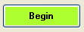 | Starting Data Logging  Click on the Begin button to start data logging. The program prompts the user to enter a file name to save the run data to. The number of logged data points is updated as points are saved.
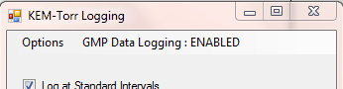 |  | The user has two options for the type of data file that is created. KEM-Torr software can log data to either a compliant or non-compliant data file. Logging data to a GMP compliant data file requires a little more CPU power, but the user will probably not note any change.
Non-GMP Compliant Data File – This is a standard data file that’s logged to Excel in a .csv file format. This file can be open with excel and manipulated in any way.

GMP Compliant Data File – A GMP compliant data file is identical to the non-compliant file, except at the end of the file are appended encrypted hash codes that are unique to each data file. In this case, GMP compliance doesn’t mean that a user is prevented from changing a data point, for example changing a recorded pressure from “760.0 torr” to “300.0 torr”, but that ANY change to file is irreversible detectable. KEM-Torr contains a utility that reads the entire data file and then compares that file to the encryption codes saved with the file. If the file matches the encryption codes, then this is a guarantee that no change has occurred to the file since its original creation. If the file does not match the encryption codes, KEM-Net states that the file has been changed since its’ original collection date.

To test a file for data integrity, after the file is closed and no longer logging data, select Run Time -> :Logging -> Log File Integrity -> Verify Log File. You’ll be prompted to select the log file of interest, then KEM-Net will state that the file has not been changed since its original creation, or that it has been changed.
To enable GMP data logging, see the section titled Customizing the DVR-1000 Software.
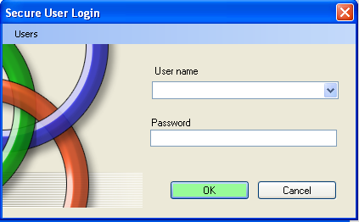 |  |  | When GMP compliant data logging is selected, the user is prompted to enter their user name and password.  New users can be added by selecting the menu option “Add New Users” from the Users menu.  Existing users can be deleted by selecting the menu option “Delete Users” then following the on-screen instructions.
Customizing the DVR-1000 software

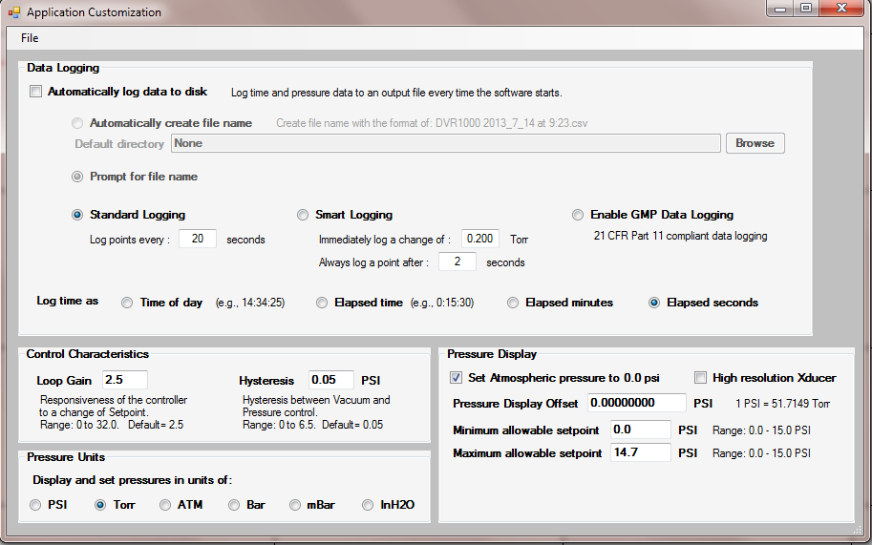 | Several parameters of the KEM-Torr can be specified as user defaults. To open the customization screen, select Enable Configuration Menu from the Configuration menu, then select Customize.

Data Logging Controls
 | If this option is selected, the controller automatically starts to log time and pressure data to disk as soon as the user starts the control action of the controller by unchecking the “Stop Control” check box.
 | If the option “Automatically create file name” is selected, when data logging starts, the user is not prompted for a file name to save data to, but the system creates a file name based on the current date and time. If this option is not selected, when data logging starts, the user will be prompted for a file name to save data to.
Default Directory | Optionally, the user can enter a default directory to save all data files to.
Log time as: | In the log file, time data can be recorded in any of 4 formats.  Time of day – In this format the time the data point is collected is saved at the actual time of day, for example, “4:15 PM”.  Elapsed time – This option saves the time that the data point is collected in the format of “Hr : Min : Sec” since the start of the data collection.  Elapsed minutes – This option saves the time data point as a decimal value of minutes since the start of the data collection.  Elapsed seconds – This option saves the time data point as in integer value of seconds since the start of the data collection.
Type of Data Logging | When logging is set to start automatically, the selection of these variables is used for the logging session.  Standard Logging  Smart Logging  For a discussion on the nature and differences of these two logging methods, see the section above titled Logging Pressure Data.

Enable GMP Data Logging | When data is logged, it can be logged to a simple Excel .csv file in a human-readable, but unsecure file format, or data can be logged into the same file, but with appropriate encryption keys that the file complies with 21 CRF, Part 11 requirements for data logging (GMP Compliant).  The file is still human-readable, but appended to the end of the file are codes that will detect if the text of the file is changed in any way.  To enable GMP data logging, check the radio button.

Control Characteristics
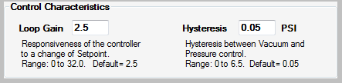 | The Loop Gain sets how responsive the controller is to a  deviation of the
system pressure from the setpoint pressure.. Low values product slow, but stable adjustments to bring the system pressure to the setpoint. High values result in a fast response to a deviation from setpoint, but can also result in unstable control. The default value is 2.5.
Hysteresis – Dual valve controllers have a vacuum and pressure valve. The algorithm controlling the valves must know how much deviation from the setpoint is required to switch between the two valves.
For example, if a flask is being regulated at –10.00 psi, if the flask pressure fell to -10.01 PSI (under pressure), it would not be a good idea to open the pressurization valve with the expectation that the value would inject just the right amount of air to raise the pressure from –10.01 to –10.00 PSI. When the flask is at vacuum pressures, hysteresis is the amount that the flask pressure must be below the setpoint before the pressurization valve is activated to correct for the under-pressure condition. Also, when the flask is at positive pressures, hysteresis is the amount that the flask pressure must be above the setpoint before the vacuum valve is activated to correct for the over-pressure condition. The default value for hysteresis is 0.05 PSI. Hysteresis has no affect on how precisely the pressure is regulated in the flask; the Infinity always attempts to regulate the flask pressure to 0.01 PSI.

Pressure Units
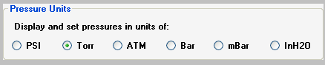 | Specifies the default units for pressure display, data logging, and charting. After selecting the desired unit, the software must be exited and restarted for the change to take effect.
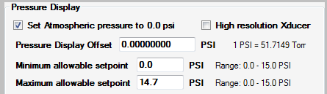 | The user can select to display atmospheric pressure (ATM) as 0.0 or 14.7 psi. If ATM is displayed as 0.0, then vacuum pressures are entered as negative numbers (i.e., 5 psi below ATM is
entered as –5.0 (-259 torr) and full vacuum is –14.7 psi (-760 torr). A user offset can be added to the displayed pressure to correct a pressure error present in the display. If a display error is larger than 0.2psi, the controller may need to be recalibrated.
Some controllers are supplied with a custom high resolution transducer. Do not check this box unless instructed to do so by J-KEM Scientific.

The user can restrict the vacuum setpoint values that can be entered into the controller on the main screen. For example, the user can set the minimum allowable setpoint to a value no lower than 1.5 PSI or to a value no higher than 12.0.

Vacuum Regulator Configuration and Calibration
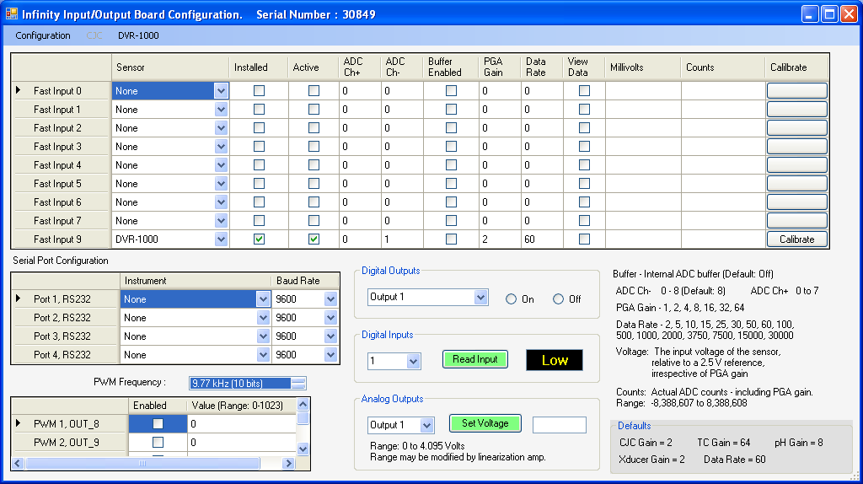 |  | The Infinity board inside of the DVR-1000 is a highly versatile board capable of multiple functions. As can be seen, most of the functionality of the Infinity board is not used for the DVR-1000, but if your application has special requirements, please contact J-KEM for more information.

Only one analog input is enabled for the DVR, and that input connects to the pressure transducer. The parameters for this input are locked so that they cannot be inadvertently changed. The only control that is not locked is the Calibrate button. Prior to calibrating the controller, you must make sure that you have the appropriate pressure calibrator available.
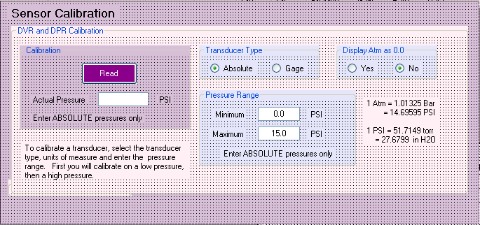 | Click the calibration button to open the calibration input screen. Connect the vacuum transducer to a vacuum source and lower the pressure to any value below 0.01 psi. Enter the actual system pressure in the box titled “Actual Pressure” and then click the Read button.  Note: Pressures must be entered as Absolute pressures and in units of PSI. Absolute pressure specified full vacuum as 0.00 and 1 atmosphere as 14.69 psi.
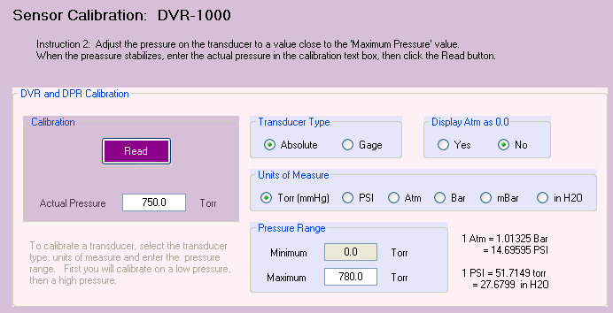 | Now remove the vacuum source and allows the vacuum transducer to set at atmospheric pressure. Enter the current barometric pressure in the box titled “Actual Pressure” and click the Read button.  Remember, pressures must be entered as Absolute pressure, so enter the actual barometric pressure, which is probably not 14.69 psi (i.e., exactly 1 atmosphere).
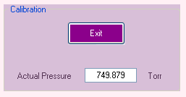 | The regulator now begins to display the sensed pressure on the vacuum transducer. When you are satisfied that the calibrated pressure is reading properly, click the Exit button.

Remote Control of the Infinity Controller

The infinity controller does not require KEM-Torr software to run. For users that want to incorporate the Infinity controller into a larger automation system, the controller can be operated by means of ASCII serial commands.

The controller only accepts one set of communication settings:
Baud: 115200
8 data bits
1 stop bit
No parity
No hardware handshaking.

Understanding the Pressure Unit System Used by the Infinity Controller
Pressure units are entered, and pressure readings are reported in units of “PSI x 10,000”, where atmospheric pressure is reported as 0.00 psi.
So, for example, atmospheric pressure is reported as “0.000”, full vacuum is reported as –146766, and positive 6.5 psi (i.e., 6.5 psi above atmospheric pressure) is reported as 65000.

A pressure of “-53456” is –5.3456 psi, or 483.6 torr [760.0 – (-5.3456 psi * 51.714924 torr/psi)].

Command Set
Note that all commands are case sensitive and are all capital letters. Commands are terminated with carriage return (0x13). The replies to commands, start with the command sent, then any returned data is appended to the returned command string.
Command | Range | Example | Reply | Comments
PCACP | None | PCACP\r | PCACP-1845\r | This command queries the current sensed pressure. The sensed pressure in this example is –1845, or –0.1845 psi.  For the DVR-1000 and DDR-1200, pressures are reported as Absolute pressures, while the DPR-1100 reports pressures as gage pressures.
PCASP | -150,000 to 2,500,00  None | PCASP-100000\r  PCASP\r | PCASP-100000\r  PCASP-10034r\ | This command both sets or queries the current setpoint pressure. Pressure units are ABSOLUTE pressure in PSI x 10,000. When no value follows the PCASP command, the current setpoint pressure is returned in the reply. When a value follows the PCASP command, this sets the current setpoint pressure to the passed value.  A command of PCASP-100000 sets the setpoint of –10.00 psi , or 242.9 torr.  Queries the current setpoint pressure.

PCARN | 0 to 3 | PCARN2\r | PCARN2\r | This command starts or stops pressure control. The argument passed with the command depends on the type of Infinity controller in use.
Digital Vacuum Regulator, DVR-1000 – If the regulator is fitted only with a vacuum proportioning valve, the command PCARN2 starts vacuum control. If the DVR-1000 has the optional back-fill valve, then the command PCARN3 starts vacuum control and back-fill control.
Digital Pressure Regulator, DPR-1100 – The command PCARN1 starts pressure regulation.
Dual Range Pressure Regulator, DDR-1200 – The command PCARN3 starts both vacuum and pressure regulation.
The command PCARN0 stops pressure regulation in all model numbers.
PWM4D | None | PWM4D\r | PWM4D692\r | This returns a digital value that is representative of the voltage applied to the vacuum proportioning valve. A value of 0 means no voltage is applied to the valve, a value of 4095 means that 24 Vdc is applied to the valve.
PWM2D | None | PWM2D\r | PWM2D692\r | This returns a digital value that is representative of the voltage applied to the pressure proportioning valve. A value of 0 means no voltage is applied to the valve, a value of 4095 means that 24 Vdc is applied to the valve.
PINFO | None | PINFO\r | MFC V3.1,12-Apr-13,4.116\r | Queries product information and program date. This is a good command to verify that you have serial communication with the controller
PCAHP | -150,000 to 2,500,000 | PCAHP-140987\r | PCAHP-140987\r | Set the low pressure calibration point. To calibrate the controller, 1) introduce a known low pressure point, (close to full vacuum) and then send the pressure in PSI x 10,000 as an absolute pressure.  So, for example, if the low pressure standard point is 1.2 torr, then send the command:  PCAHP-146727\r
PCALP | -150,000 to 2,500,000 | PCALP-213\r | PCALP-213\r | Set the high pressure calibration point. To calibrate the controller, 1) introduce a known pressure point close to atmospheric pressure and then send the pressure in PSI x 10,000 as an absolute pressure.  So, for example, if the high pressure standard point is 758.9 torr, then send the command:  PCAHP-213\r

Here is a reasonable startup sequence:

PINFO - Tests to make sure you have serial communications
PCASP##### - Send in a new setpoint
PCARN3 (or PCARN1, or PCARN2. Use the appropriate command) - Start pressure control
PCACP - The command queries the current sensed pressure.

New pressure setpoints can be sent at any time
To create a ramp, send in a timed sequence of setpoints to create the desired pressure ramp.
To stop pressure control and close both the vacuum and pressure control valves, send the command PCARN0.

