Temperature Control for Research and Industry

DM120 Manual

Warranty
J-KEM Scientific, Inc. warrants this unit to be free of defects in materials and workmanship and to give satisfactory service for a period of 12 months from date of purchase. If the unit should malfunction, it must be returned to the factory for evaluation. If the unit is found to be defective upon examination by J-KEM, it will be repaired or replaced at no charge. However, this WARRANTY is VOID if the unit shows evidence of having been tampered with or shows evidence of being damaged as a result of excessive current, heat, moisture, vibration, corrosive materials, or misuse. This WARRANTY is VOID if devices other than those specified in Section 3.2 are powered by the controller. Components which wear or are damaged by misuse are not warranted. This includes contact points, fuses and solid state relays.
THERE ARE NO WARRANTIES EXCEPT AS STATED HEREIN. THERE ARE NO OTHER WARRANTIES, EXPRESSED OR IMPLIED, INCLUDING BUT NOT LIMITED TO THE IMPLIED WARRANTIES OF MERCHANTABILITY AND OF FITNESS FOR A PARTICULAR PURPOSE. IN NO EVENT SHALL J-KEM SCIENTIFIC, INC. BE LIABLE FOR CONSEQUENTIAL, INCIDENTAL OR SPECIAL DAMAGES. THE BUYER'S SOLE REMEDY FOR ANY BREACH OF THIS AGREEMENT BY J-KEM SCIENTIFIC, INC. OR ANY BREACH OF ANY WARRANTY BY J-KEM SCIENTIFIC, INC. SHALL NOT EXCEED THE PURCHASE PRICE PAID BY THE PURCHASER TO J-KEM SCIENTIFIC, INC. FOR THE UNIT OR UNITS OF EQUIPMENT DIRECTLY AFFECTED BY SUCH BREACH.

Service
J-KEM Scientific maintains its own service facility and technical staff to service all parts of the controller, usually in 24 hours. For service, contact:

J-KEM Scientific, Inc.
858 Hodiamont Ave.
St. Louis, MO 63112 USA
(314) 863-5536
FAX (314) 863-6070
Web site: http://www.jkem.com
E-Mail: jkem911@jkem.com

Quick Operating Instructions

The two steps below are the basics of using your temperature monitor. For additional information or implementing additional functionality, contact J-KEM.

1 | Place the thermocouple in the solution being heated. Place at least the first 1/4” of the thermocouple directly in the solution being heated. Thermocouples can be bent without harming them. If you’re heating a corrosive liquid, use a Teflon coated thermocouple. This monitor must be used with the proper thermocouple type for accurate temperature displays.  If the thermocouple jack on the back of the monitor is:  BLUE it must be used with a type T thermocouple.  YELLOW it must be used with a type K thermocouple.  BLACK it must be used with a type J thermocouple.  Turn power on to the temperature monitor.
2 | Enter an over-temperature alarm  setpoint (i.e., the temperature at which the over-  temperature alarm sounds). This unit is equiped  with an audible alarm that sounds when the  reaction temperature exceeded a user entered high  temperature limit. To enter an alarm setpoint,  hold in the * button and simultaneously press the  ↑ key to increase or the ↓ key to decrease the setpoint. The setpoint can be seen at any time by  holding in the * button, the setpoint appears as a blinking number in the display.  The over-temperature alarm cannot be disabled,  but if you do not want to use this feature simply  enter a setpoint of 400° C, which virtually  guarantees that an over-temperature condition will  not be reached.

KEM-Net Data Logging and Control Software

The USB port on the back panel of the controller is an interface to J-KEM’s KEM-Net Software. KEM-Net is free and can be downloaded from J-KEM’s web site at www.jkem.com.
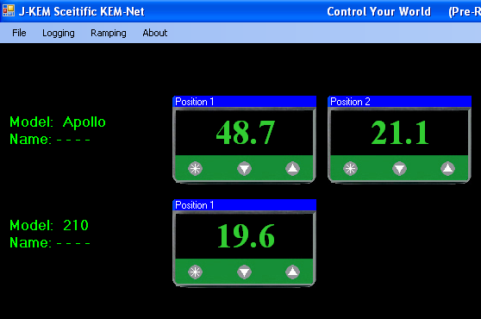 | KEM-Net provides remote control of up to 8 controllers, graphical presentations of each digital meter and time & temperature plots. Highlights of KEM-Net include:  * GLP and GMP compliant data logging  * Runs a 12 step temperature ramp  * Logging of Time and Temperature  * Logging of % Power for Exo and Endotherm detection  * Program KEM-IO Actions (Section 3.10)  * Over- & Under-temperature alarm functions.
KEM-Net also includes a virtual comm port driver that provides a simple ASCII interface to operate and data log the controller from LabView or other software packages.

New Features:
GMP compliant data logging
Exo and Enotherm monitoring

KEM-IO Remote Control of Laboratory Equipment based on Time and Temperature
KEM-IO is an optional feature that allows the controller to respond to inputs from instruments, like a vacuum sensor or a hood door switch, and also to control instruments, like stirrers and chillers based on reaction temperature. KEM-IO automates programs as simple as:

Heat my reaction to 80º C, then turn on my peristaltic pump to add reagents.

or as sophisticated as:

Turn on my stirrer, then ramp my reaction from 25º C to 100º C if 45 minutes, hold for 2 hours, then turn off heating. When the reaction cools to 50º C, turn off the stirrer. If at any point the reaction exotherms and heats above 110 ºC, turn on my chiller and keep it on until I manually reset the system.

Contact J-KEM for additional information.

